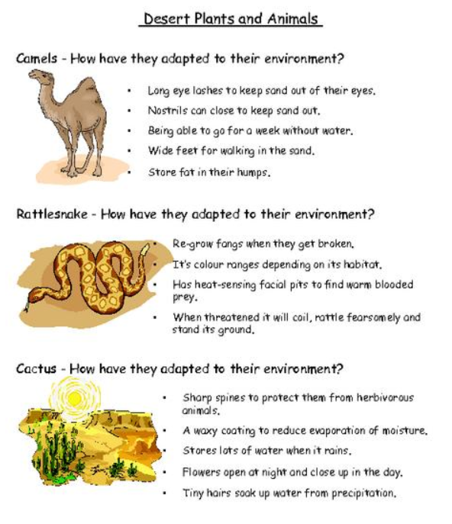
Put S, P or B next to each of the following adaptations to classify them as Structural, Physiological or Behavioural.

Read the information on the next page and write the adaptations in their correct category.
Structural | Physiological | Behavioural

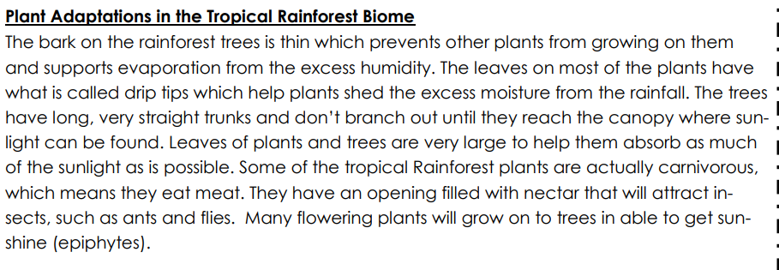
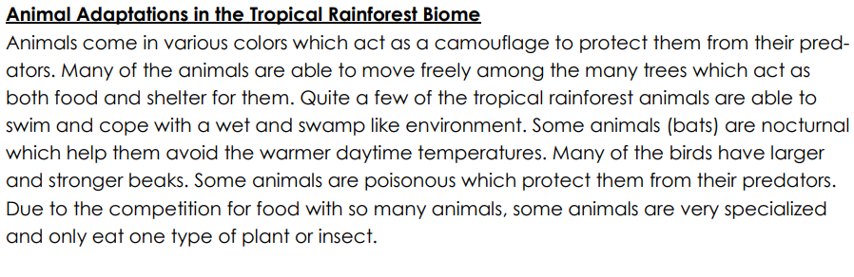
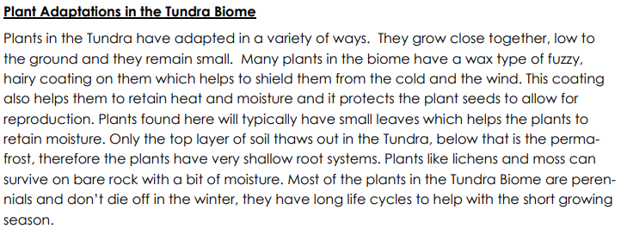
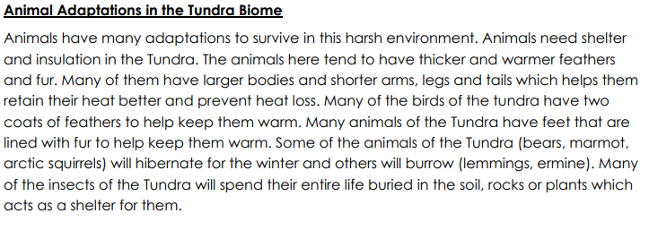
Things needed for Natural Selection
Read the text below and fill in the table.
Some red-bellied black snakes are longer than others. Head size also varies and limits the size of the prey the snake can eat. Snakes sometimes eat cane toads, which are toxic. Larger cane toads are more toxic than smaller ones. Snakes with larger bodies can cope with higher levels of toxin. Red-bellied black snakes lay up to 18 live babies at a time, but many won’t survive to reproduce. Because longer snakes with smaller heads survive better in areas with cane toads, they are able to reproduce more. The longer length and smaller head traits are passed on to their offspring and become more common in the population.
Letter | Word | Meaning | Part from the example which matches
D |  | Animals have different traits, originally would have been caused by mutations
I |  | Genes are passed onto offspring
S |  | Things in the environment that organisms compete for or can affect survival
C |  | Not all animals can survive so only the fittest survive and pass on genes

Match the word to the correct definition and put it in the box.
Mutation, Evolution, Adaptation, Charles Darwin, Diversity, Fitness, Natural selection
Differences between and within species
Scientist who developed the theory of evolution and ‘survival of the fittest’
The process by which evolution happens and species adapt
A trait that helps an animal survive or reproduce in it’s habitat
When an organism survives and reproduces, the higher number of offspring the higher their …
Change over time as animals adapt to their environment
A sudden change in the DNA of an organism

Evidence for evolution
Fill in the following table:
Type of evidence | How it gives us evidence for evolution: | Example:
Fossils
DNA/Genetics
Embryology
Homologous structures

